**INTRODUCTION TO AI**

**CASE STUDY/ MINI PROJECT**

**ASSIGNMENT**

***BY***

**SUSHANT KUMAR JHA (22225007), 3MCA**

**SUBMITTED TO- DR. ANJALI MATHUR**



**SCHOOL OF SCIENCES**

**2022-2024**

Code:

pip install chess

import chess

board=chess.Board()

board

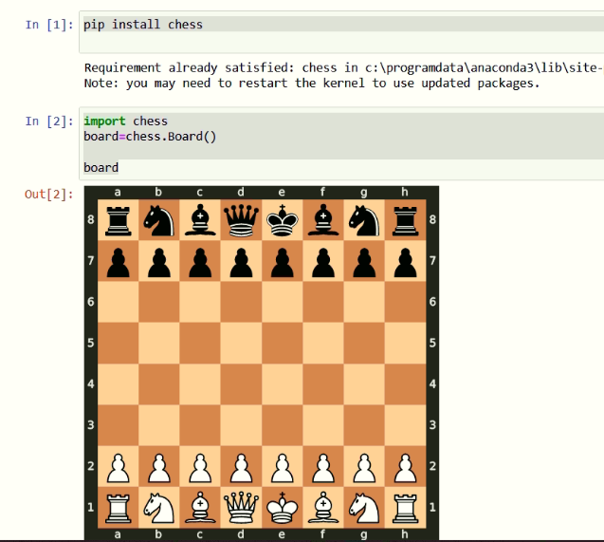

import chess

board=chess.Board()

board.legal_moves

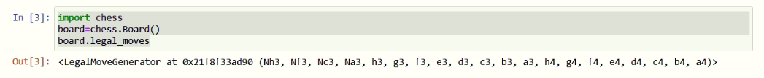

import chess

board=chess.Board()

board.push_san("e4")

board

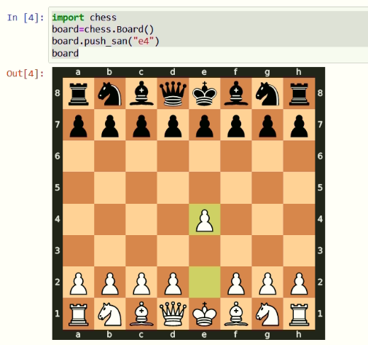

import chess

board=chess.Board()

board.push_san("e4")

board.push_san("e5")

board

